CENWP-OD 05 November 2010

MEMORANDUM FOR THE RECORD

Subject: DRAFT minutes for the 04 November 2010 FPOM task groups meeting.

The meeting was held in the Celilo (basement) Room at CRITFC, Portland OR. In attendance:
Last | First | Agency | Office/Mobile | Email
Bettin | Scott | BPA | 503-230-4573 | swbettin@bpa.gov
Benner | David | FPC | 503-230-7564 | dbenner@fpc.org
Caudill | Chris | Univ. Idaho |  | caudill@uidaho.edu
Clugston | David | USACE-NWD | 503-808-3727 | David.a.clugston@usace.army.mil
Cordie | Bob | USACE-TDA | 541-506-7800 | Robert.p.cordie@usace.army.mil
Dick, Jr. | Roger | Yakama | 509-945-0771 | rdii@yakama.com
Ellis | Stuart | CRITFC | 503-731-1312 | stue@criftc.org
Fredricks | Gary | NOAA | 503-231-6855 | Gary.fredricks@noaa.gov
Fryer | Jeff | CRITFC |  | fryj@critfc.org
Hausmann | Ben | USACE-BON | 541-374-4598 | Ben.J.Hausmann@usace.army.mil
Klatte | Bern | USACE-NWP | 503-808-4318 | Bernard.a.klatte@usace.army.mil
Kruger | Rick | ODFW | 971-673-6012 | Rick.kruger@coho2.dfw.state.or.us
Lorz | Tom | CRITFC | 503-238-3574 | lort@critfc.org
Mackey | Tammy | USACE-NWP | 541-374-4552 | Tammy.m.mackey@usace.army.mil
Ploskey | Gene | PNNL | 509-427-9500 | Gene.ploskey@pnl.gov
Rerecich | Jon | USACE-BON | 541-374-7984 | Jonathan.g.rerecich@usace.army.mil
Schwartz | Dennis | USACE-BON | 541-374-4567 | Dennis.e.schwartz@usace.army.mil
Volkman | Eric | BPA | 503-230-3182 | etvolkman@bpa.gov
Whiteaker | John | CRITFC |  | whij@critfc.org
Wills | David | USFWS | 360-604-2500 | David_wills@fws.gov
Caudill, Hausmann, and Ploskey called in.

- Finalized results from this meeting.
  - The task group will take to FPOM the recommendation that the fishery go forward for 2011.
  - The task group will reconvene in March to discuss future modifications or even at different locations.
  - The task group recommended scrapping TIES. If performance objectives are not met, new TIES would be designed.
  - The AFF task group will meet after the December FPOM meeting.

- The following documents were provided or discussed. Documents may be found at http://www.nwd-wc.usace.army.mil/tmt/documents/FPOM/2010/
  - Agenda, Fish Passage O&M task groups.
  - Shad fishery fallback data from Cordie.
  - TIES data from Schwartz and Ploskey.

- Action Items
  - [Nov 10] Shad fishery. ACTION: Cordie will summarize the fallback data.
  - [Nov 10] Shad fishery. ACTION: Dick, Jr. will talk with his policy folks to get a policy decision for the March meeting.
  - [Nov 10] Shad fishery. ACTION: Caudill will forward on any reports or preliminary data for the March discussion.
  - [Nov 10] TIES. ACTION: BON Project will scrap the TIES.
  - [Nov 10] AFF task group. ACTION: Fryer will complete an analysis of passage for an equal time as sampling, separating sample with non-sample by an hour.
  - [Nov 10] AFF task group. ACTION: Klatte will provide the list of AFF improvements. The task group will edit and prioritize the list. STATUS: completed.
  - [Nov 10] AFF task group. ACTION: Mackey will include pictures of the brail pool and exit in the meeting minutes. STATUS: completed.

- Shad Task Group. (Chair- Cordie. Members- Benner, Dick, Fredricks, Kruger, Lorz, Mackey, Meyer, Welch, Wills)
  - Cordie presented information showing that the start of the fishery coincides with increased salmon fallback. The net shape was changed and the fishery protocols were adhered to in 2010. Bettin suggested a purse seine set-up to move fish away from the exit prior to dip netting.
  - Dick, Jr. talked about how the fishery is important to the tribal fishers. He said the suggestion to end the shad fishery is a policy decision and isn’t one that would be made by a technical group. Ellis said there is no CRITFC staff member present who can make the decision to end the fishery as that is a policy decision.
  - Bettin asked if the group was discussing the location or the fishery? Fredricks said we are just discussing whether or not the fishery should occur at The Dalles.
  - Ellis said the policy people will want to know the mortality associated with the fishery. If we cannot give a mortality estimate, then the policy folks will need to know if the fallback impacts are significant enough to out-weigh the benefits of fishing for shad. Further, if there is a mortality number given, the tribes may decide to just add that number to their fishery permit. The coverage is written such that the mortality can just be added to the catch numbers.
  - Cordie said with the numbers available, there doesn’t seem to be a way to establish mortality. Fredricks said there isn’t and ESA deals with more than mortality, it deals with take as well and take includes harassment. Fredricks expressed concern about the precedent set by just absorbing any estimated mortality.
  - Dick, Jr. suggested there is a good market and even though the fishery hasn’t been successful, the guidelines established have been successful in regulating the fishery. He doesn’t believe the Yakama’s will give up on this fishery, especially since the last couple of years have been perceived as being weird, e.g. flows, weather, etc. He said the fishers still believe they can modify the net or work on setting it differently to have fewer impacts. Ellis said there isn’t much money to test new ways of fishing for shad. Fredricks asked how much, Ellis suggested it might not be much, maybe $10K. Bettin asked if the buyers would invest in that effort. Ellis said no. Another struggle is having fishermen available for the shad fishery. ACTION: Dick, Jr. will talk with his policy folks to get a policy decision for the March meeting.
  - Wills requested a summary of the fallback data. ACTION: Cordie will summarize the data available. Fredricks said everyone probably has the goal of removing shad from the system but we need to figure out how to do that without impacting salmon.
  - Dick, Jr. asked about the split of fish passing TDA-N versus TDA-E. Fredricks said the chinook used the north ladder a bit more but the smaller fish still favored the east ladder.
  - The task group recommends the fishery go forward for 2011; they will reconvene in March to discuss future modifications or even at different locations.
  - Caudill said University of Idaho had tagged shad in 2010 with leftover radio tags but nothing was officially funded. A report will be out sometime in the next year or so. Fredricks suggested finding some catch to get money funneled into addressing shad. Bettin suggested there may be NOAA grants available. Fredricks didn’t know of any. ACTION: Caudill will forward on any reports or preliminary data for the March discussion.
  - Cordie asked if the Yakamas had looked at the JDA forebay when the tuffboom was out there. He suggested there were a lot of shad in that area and they would not swim under the boom. Dick, Jr. said some of the fishers looked at it but had concerns about how the fish might be removed. Cordie said that could probably be worked out but there isn’t a tuffboom there anymore.

- TIES Task Group. (Chair- Klatte. Members- Benner, Bettin, Fredricks, Hausmann, Kruger, Lorz, Mackey, Meyer, Schwartz, Wills)
  - Schwartz provided historical FGE, recent FGE and additional background information for discussion. Ploskey went through the data presented (also attached to these minutes). Wills and Fredricks took turns attempting to tax people’s memories by bringing up information from a decade to two decades ago. Based on the belief by USACE that BiOp performance measures could be met without the TIES, the task group gave the go-ahead to remove TIES and potentially scrap them as they did not provide a significant benefit to migrating juveniles at PH2.
  - Bettin asked if the TIES would be stored or would new TIES be made. Klatte suggested shrink-wrapping the TIES in the event they may need to be re-installed, to prevent further degradation. Schwartz suggested the TIES would need to be evaluated to see if they could sit for three more years. New TIES would be wrapped up within the CRFM program.
  - The task group recommended scrapping TIES. If performance objectives are not met, new TIES would be designed under the CRFM program.

- BON AFF. (Chair- Mackey. Members- Fredricks, Kiefer, Kruger, Lorz, Marvin, Meyer, Rerecich, Wills)
  - No anticipated change forms for the 2011 FPP at this time. Fryer said he will need to look at the data first. The sample size has been dropping. Fredricks said the new NOAA permits have a handling cutoff at 70°F. The FPP may say something different but the permit says 70°F.
  - BON Fisheries concerns about the jack bias analysis still need to be addressed. Fredricks suggests looking at radio-tagged fish with the parallel leads in and with them out. This wouldn’t happen until 2012. Fryer said he feels the data is pretty clear and the it is all available to the public on PITAGIS. Caudill suggested RT might not provide the level of resolution within the ladder to determine if fish are going up one side or the other of the ladder. Lorz suggested USACE run the analysis BON Fisheries is requesting. Caudill suggested using HD PIT tags to get the information requested. University of Idaho can install the HD antennas during the winter.
  - Rerecich clarified that Fryer looked at fish passage during trap operation versus non-trap operation. Rerecich and Fryer further discussed what Fryer’s analysis showed. Both acknowledged the bias associated with the fish jumping into the flume and the switchgate operator bias. Rerecich stated that what is known is that the parallel leads create a better environment for fish passage and still allow the AFF users to get a decent sample. Fryer said he wants to minimize handling of fish at the trap.
  - Mackey said there was a request a year ago to look at same hours different days because a decision was made, based on one year’s worth of data to pull the parallel leads with no complete analysis. Hausmann said the analysis should have at least looked at the same length of time rather than compare four hours of sampling to 20 hours of non-sampling time. The analysis should have been done just to provide a complete record so when future biologists look at the decision to pull leads, the data is clear. Fryer said he could do it but said it seems a silly and useless analysis. Fredricks said BON Fisheries has the final decision to put the leads back in and if it only takes a simple analysis then do it and move on. Hausmann recommends the closest four hours to the sample hours. Fryer said all bias can be removed by dropping all four picket leads. Most of the task group pointed out that the goal is to not drop all four leads. Fryer said he agrees. ACTION: Fryer will complete an analysis of passage for an equal time as sampling, separating sample with non-sample by an hour.
  - Fredricks started the discussion about the increased mortality in 2010. He acknowledged there may be outside influences but for right now, he wants to address the fact that fish are dying at the AFF. ACTION: Klatte will find the list of potential mods so everyone may review, edit and prioritize the list. Mackey will include pictures of the brail pool and exit in the meeting minutes.
  - The task group will meet to discuss potential mods, funding, etc at the next meeting, which will follow the 9 December FPOM meeting.
TIES task group info.

FGE Considerations:

Historic netting and hydroacoustic data indicate that FGE is about 10% high at intakes between TIES than at intakes between TIES. Acoustic telemetry estimates may support this for CH1 but not for STH.
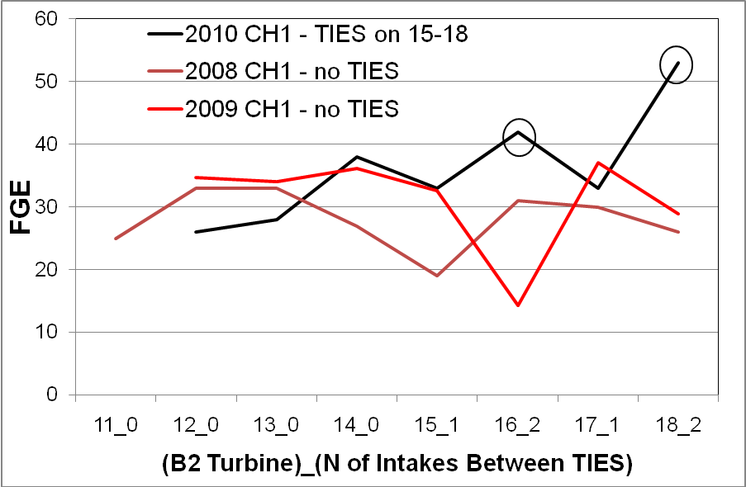
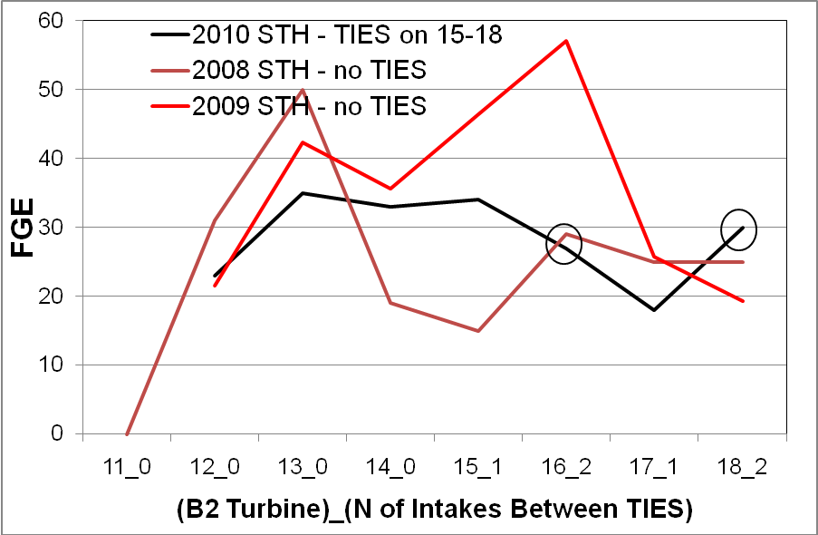
Horizontal Distribution of Passage Considerations:

There is considerable empirical evidence indicating that passage distributions tend to be higher at the south end of B2 than at the north end. Lateral flow along the face of B2 toward the south is considered to be very important to maintaining high B2CC passage, which is why removal of TIES from turbines 11-14 was recommended previously.

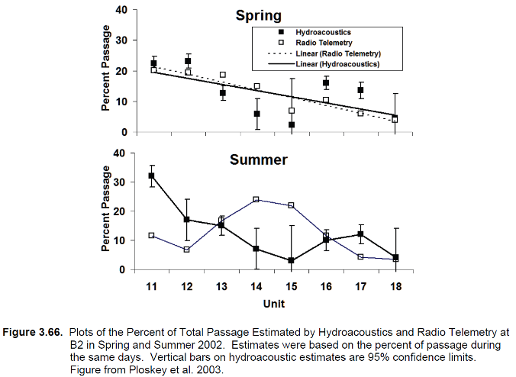
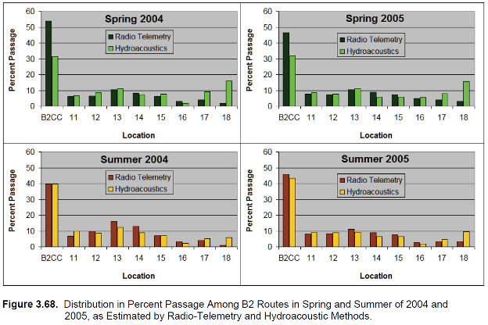
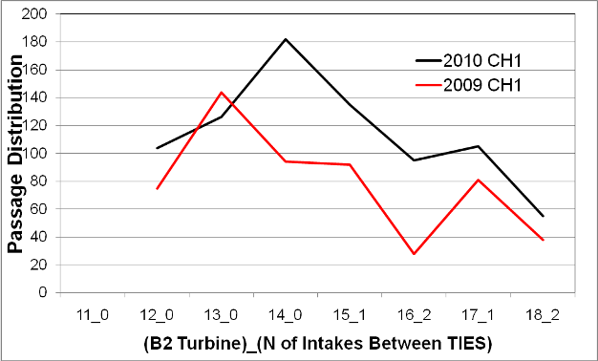

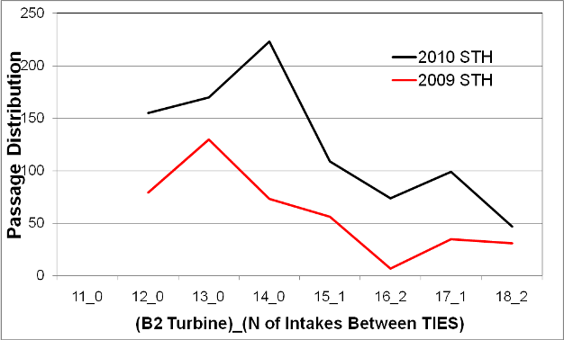

Unit 11 was off in both years.
Passage survival considerations:

Table 3.1: Survival of yearling Chinook salmon, juvenile steelhead and subyearling Chinook salmon that passed various routes at Bonneville Dam from 2008 to 2010, including the 95% CL on the survival estimate in parentheses. Unless otherwise indicated, estimates were derived from paired-release Cormack-Jolly-Seber recapture models that used control releases of fish in the tailrace of Bonneville dam.

Yearling Chinook Salmon
Year |  | B2 |  | CC |  |  |  | JBS |  |  |  | B2Turb |  |  |  | Dam
2008 |  | 1.005 (0.030) |  | 1.021 (0.034) |  |  |  | 1.017 (0.045) |  |  |  | 0.979 (0.037) |  |  |  | 1.001 (0.025)
2009 |  | 0.986 (0.008) |  | 0.996 (0.004)** |  |  |  | 0.988 (0.013) |  |  |  | 0.970 (0.020) |  |  |  | 0.962 (0.011)
2010 |  |  |  |  |  |  |  |  |  |  |  |  |  |  |  | 0.964 (0.015)**
Juvenile Steelhead
Year | B2 |  |  |  | CC |  |  |  | JBS |  |  | B2Turb |  |  |  |  | Dam
2008 | 0.982 (0.019)** |  |  |  | 0.984 (0.027)** |  |  |  | 0.984 (0.039)** |  |  | 0.982 (0.024)** |  |  |  |  | 0.972 (0.01)²**
2009 | 0.979 (0.026) |  |  |  | 0.992 (0.011)** |  |  |  | 0.977 (0.041) |  |  | 0.951 (0.049) |  |  |  |  | 0.970 (0.013)²
2010 | * |  |  |  |  |  | * |  |  | * | * |  |  |  |  |  |  | 0.956 (0.016)**
Subyearling Chinook Salmon
Year |  | B2 |  |  |  | CC |  |  |  | JBS |  |  | B2Turb |  |  |  |  | Dam
2008 |  | 0.981 (0.016) |  |  |  | 0.996 (0.016) |  |  |  | 0.991 (0.024) |  |  | 0.954 (0.020) |  |  |  |  | 0.970 (0.014)²
2009 |  | 0.991 (0.063)*** |  |  |  | 0.942 (0.054)** |  |  |  | 0.933 (0.087)*** |  |  | 0.998 (0.079)*** |  |  |  |  | 0.959 (0.063)²***
2010 |  | * |  |  |  | * |  |  |  | * |  |  |  | * 0.952 (0.023)**
* Data not available
** Single Release Estimate
*** Relative release estimate, using fish passing the Corner Collector as the paired control fish
² Dam estimate includes forebay mortality

B2 TIES In vs TIES out Synthesis Data

EVALUATION OF TURBINE INTAKE MODIFICATIONS AT THE BONNEVILLE DAM SECOND POWERHOUSE, 2002

EXECUTIVE SUMMARY
In 2000, the U.S. Army Corps of Engineers conducted hydraulic model studies to evaluate flow in the second powerhouse intakes at Bonneville Dam. As a result of these evaluations, three modifications were proposed to increase upward flow toward the intake gatewells:

- Increase the size of the vertical barrier screen (VBS) by removing a portion of the concrete beam below it.
- Install a turning vane below the picking beam on the submersible traveling screen (STS).
- Install a gap-closure device on the intake ceiling downstream from the top edge of the STS.

In addition, to meet new design criteria for salmonid fry established by NOAA Fisheries, screen mesh openings on the new VBS were decreased to reduce impingement of fry. In 2001, with all three of these modifications installed in the B and C gatewells of unit 15, we measured fish guidance efficiency (FGE), orifice passage efficiency (OPE), and fish condition. Mean FGE was 71% for yearling chinook salmon and over 80% for steelhead and coho, the highest values measured at the second powerhouse since testing began in the early 1980s. Improvements in FGE were similar for subyearling chinook salmon. OPE was high for yearling chinook salmon in the spring (94%) and for subyearling chinook salmon in the summer (99%). All fish in the 2001 OPE tests were PIT-tagged, so passage times from release in the gatewell to the detectors at the downstream smolt-monitoring facility could be measured. Median passage time for the 10 replicate tests averaged 1.6 and 0.8 h for yearling and subyearling chinook salmon, respectively. For each species, there was no significant difference between unit 15 and an unmodified unit for either OPE or passage time. During FGE and OPE tests, descaling and injury rates were low for all species, with no significant differences between the modified and unmodified units. Because of these promising results, the same three intake modifications were installed in turbine unit 17 to determine if the results obtained in the middle of the powerhouse (unit 15) could also be achieved along the northern shoreline, where eddies and cross currents in the forebay were thought to reduce FGE. For all species tested during spring 2002,

*FGE was higher in gatewell 17B, with no turbine intake extension (TIE), than in either gatewell with a TIE (17A and 17C). Differences were significant iv (P = 0.05) for yearling chinook salmon among all three gatewells. Respective mean FGEs for yearling chinook, steelhead, and coho were 66, 54, and 71% in gatewell 17B (with no TIE), and 47, 49, and 51% in gatewell 17A (with TIE). Although values were not as high as those obtained in unit 15 in 2001, they were higher than those observed inunit 17 in 1994.

Mean FGE during spring 2002 was higher than in 1994 for all yearling species and for both test gatewells. For gatewell 17B, the differences between 2002 and 1994 were 14, 20, and 21% for yearling chinook salmon, coho salmon, and steelhead, respectively. For 17A the differences between 2002 and 1994 were 8, 1, and 17% for yearling chinook salmon, coho salmon, and steelhead, respectively.
*The higher FGEs observed for all species in 2002 in the gatewell with no TIE (17B) were similar to results observed for the entire second powerhouse in 1993 and 1994. During summer testing, mean FGE for subyearling chinook salmon was 57% in gatewell 17B (identical to that found in 2001 in gatewell unit 15B) and 47% in 17A. Summer FGE studies were not conducted in 1994.

During spring 2002, OPE was not as high for yearling chinook salmon (87%) as it was the previous year (94%). Structural problems with the redesigned VBSs interrupted testing and thus reduced the number of replicates. During FGE and OPE tests, descaling and injury rates were low for all species, with no significant differences between the modified and unmodified unit. Release and recovery of fry-sized coho salmon into the bypass pipe and to gatewell slot 15B during the last two weeks of March indicated minimal impingement or injury.

Findings

However, these tests also showed that lowering the STS 1.2 m increased the gap-net catch to 12% and reduced FGE to 29% (Gessel et al. 1986).

*From 1987 to 1989, FGE ranged from 51 to 74% (in 4-5 day test series) in units 11-13, with STSs lowered 0.8 m, streamlined trash racks, and turbine intake extensions (TIEs) installed. Based on these results, in 1991, STSs were lowered 0.8 m, streamlined trash racks were installed across the powerhouse, and TIEs were installed in alternating intake slots

In gatewell slot 17A (with TIE), FGE ranged from 23 to 88% for yearling chinook salmon (mean FGE = 47%; SE = 5.9), and mean FGE was 51% for coho salmon (SE = 6.8) and 49% for steelhead (SE = 6.4). Because of small sample sizes, no estimate was made for sockeye salmon. In gatewell slot 17B (no TIE), FGE ranged from 41 to 86% for yearling chinook salmon (mean = 66%; SE = 4.7). Mean FGE for coho salmon was 71% (SE = 5.7), and mean FGE for steelhead was 54% (SE = 5.3). Figure 4 compares the FGE from all three gatewell slots of unit 17. For yearling chinook salmon, there was a significant difference in FGE between gatewell slots (P = 0.001).

Synthesis of Bio Research on Juvenile Fish Passage and Survival at BON Dam through 2005 (Ploskey)

Almost all hydroacoustic and radio telemetry studies reflect a strong skew toward the south end of the powerhouse. With very few exceptions across season, year, or methodology, units 11-14 (especially units 11 and 12) passed the majority of fish as compared to units 15-18 on the north half of B2. As with lateral fish passage across intakes at B1, distributions across turbine intakes at B2 were not uniform.

IMPORTANT FINDINGS FROM DATA SYNTHESIS:

*Leaving turbine intake extensions (TIEs) out from units 11 through 14 undoubtedly facilitates a strong southerly flow of water along the powerhouse face toward the B2CC, and this is highly desirable forincreasing fish passage at the B2CC.

*The TIEs retained on every other intake from Intake 15A through18B help break up the flow toward the north eddy and likely increase passage and FGE at intakes between TIEs.

Turbine-intake extensions have created some predictable patterns in passage among intakes at B2, although horizontal distributions across intakes of the same turbine typically were not uniform nor predictable based on hydroacoustic sampling at B1. Discharge through Bonneville Dam turbines typically is highest at the south (A) intakes, intermediate at the middle (B) intake, and lowest at the north (C) intakes, but passage seldom follows the discharge pattern. Hydroacoustic data have sometimes shown about 10% higher passage through intakes between TIES than intakes behind TIEs at B2 (e.g., Ploskey et al. 2002c; Ploskey et al. 2003). Monk et al. (1999b) noted that FGE for yearling Chinook increased 20% for intakes between TIEs.

During B2CC operations in 2004, TIEs were not installed at units 11-14 on the south half of B2 to increase lateral flow toward the south and the B2CC, a major departure from previous operations.

B2 Forebay Hydraulic Conditions
Hydraulic conditions in the B2 forebay and at the sluice chute entrance are important to the surface flow outlet there. From qualitative observations in both the field and the 1:40 scale physical model, B2 hydraulics were unsteady with eddies and boils appearing sporadically. The dominant feature of the forebay hydraulics is the large eddy that forms in the entire half of the forebay in front of the sluice chute (Figure 3.32). This eddy turns counterclockwise and increases in intensity as powerhouse loading increases. It dissolves when one or two units are operating. The B2 forebay eddy serves to concentrate fish and debris at the southwest corner of the forebay at the sluice chute entrance.
Limited water velocity measurements were available from physical model (1:40 general) or field work in the forebay near the B2 sluice chute entrance. With the weir at El. 61 ft and forebay at El. 73 ft, calculated flow was about 2,800 cfs. Entrance velocity varied by depth; velocities were faster than shown at El. 67 and 70 ft and less for El. 64, 61, and 58 ft. Overall, entrance velocities ranged from 9 to 16 fps

*During model investigations, engineers observed distinctive hydraulic patterns with and without turbine intake extensions (TIEs). With the TIEs removed, lateral movement across the face of the powerhouse was smooth with minimal disruption before encountering the “zone of influence” of the collector entrance. With the TIEs installed, significant amounts of dye become entrained in eddies between adjacent TIEs and general turbulence levels increased.

Baseline Studies at the B2 Sluice Chute: 1990s

The hiatus in research on the B2 sluice chute between 1989 and 1995 ended with establishment of the Surface Bypass Program for Bonneville Dam. To provide baseline data for the new program, forebay distribution studies were conducted in 1995. In addition, the B2 sluice chute was tested as a prototype SFO. In 1996, 12 radio-tagged yearling and 25 subyearling Chinook salmon were contacted in the vicinity of the sluice chute entrance, but none apparently entered it (Holmberg et al. 1996). That same year, fixed hydroacoustic estimates of fish passage at the sluice chute were problematic, because of excessive acoustic noise associated with turbulent surface currents created by the turbine intake extensions (Ploskey et al. 1998). In 1997, BioSonics (1998) sampled fish passage at the sluice chute and Turbine Intake 11A to provide baseline data on chute efficiency. They also reported excessive acoustic noise from the TIEs with the weir gate at El. 61 (~3,300 cfs), but not at El. 68 (~1,100 cfs). INCA et al. (1997) recommended that the sluice chute be evaluated as a prototype corner collector in 1998, with the TIEs removed to allow for hydroacoustic monitoring of fish passage into the sluice chute with the gate at El. 61. The most influential biological test of the original B2 ice and trash sluice chute took place in 1998. During the 1998 test, the weir crest was at El. 61 ft (Figure 3.31). Thus, the entrance was 15 ft wide and about 14 ft high with discharge of 3,000 cfs, depending on forebay level. The approximate mean velocity upstream of the gate was 15.4 fps.

*Turbine intake extensions were removed at Units 11-14 to reduce turbulence at the sluice chute entrance. Removal of the TIEs also made the southerly, lateral flow lines at the face of powerhouse Units 11-14 less variable and more uniformly directed to the sluice chute entrance weir.

In 1998, the B2 sluice chute was opened and closed according to a randomized block experimental design to compare passage rates at the adjacent units (Unit 11-13). The B2 sluice chute and B2 intakes were monitored and evaluated using fixed radio telemetry and fixed hydroacoustic.

Bonneville Second Powerhouse (B2)
In 1982, with the completion of B2, the downstream migrant bypass system was activated. In 1983, initial FGE evaluations were conducted. During that era fish passage managers had established a generic FGE goal of 70% for all species. Krcma et al. (1984), using the fyke net method, reported values that generally ranged from 20%-40%, far below the stated standard. For the next two decades, numerous operations and configurations were tested as a means to improve FGE with minimal injury to fish. The conditions tested often consisted of combinations of assorted actions including raised operating gates, lowered STS, blocked trashracks, lights, reconfigured trashracks, flow turning vanes, turbine intake extensions, etc. Gessel et al. (1991) summarized results obtained from 1983-1989. Performance was improved for spring migrants with FGE attaining levels near 70%.
*The actions that resulted in the highest FGE included lowering the STS by 22 inches, streamlining the trashracks, and installing TIEs. However, FGE for summer migratory ocean-type Chinook salmon remained substandard at below 30%

Based on those early preliminary findings, TIEs were installed across the face of the powerhouse, but fish guidance performance was disappointing. Monk et al. (1999a) noted that FGE tests conducted in 1993 and 1994 with STS in place revealed that guidance of spring migrants had dropped to about 50%. This was considerably lower than the 70% observed in the late 1980s and well below the new regional standard of 80% FGE. Furthermore, results were highly variable and thus there was difficulty identifying the combination of conditions and structures that resulted in poor FGE.

REPORT RECOMMENDATIONS:

Almost all hydroacoustic and radio telemetry studies reflect a strong skew toward the south end of the powerhouse. With very few exceptions across season, year, or methodology, units 11-14 (especially units 11 and 12) passed the majority of fish as compared to units 15-18 on the north half of B2. As with lateral fish passage across intakes at B1, distributions across turbine intakes at B2 were not uniform. Leaving TIEs out from unit 11 through 14 undoubtedly facilitates a strong southerly flow of water along the powerhouse face toward the B2CC, and this is highly desirable for increasing fish passage at the B2CC.The TIEs retained on every other intake from Intake 15A through 18B help break up the flow toward the north eddy and likely increase passage and FGE at intakes between TIEs.

Turbine-intake extensions have created some predictable patterns in passage among intakes at B2, although horizontal distributions across intakes of the same turbine typically were not uniform or predictable based on hydroacoustic sampling at B1. Discharge through Bonneville Dam turbines typically is highest at the south (A) intake, intermediate at the middle (B) intake, and lowest at the north (C) intake, but passage seldom follows the discharge pattern.

*Hydroacoustic data have sometimes shown about 10% higher passage through intakes between TIEs than intakes behind TIEs at B2 (e.g., Ploskey et al. 2002c; Ploskey et al. 2003). In 2002, the B and C slots of B2 units and those intakes between TIEs at B2 had significantly higher FGE than did A slots or intakes behind TIEs, respectively. This probably is because two adjacent TIEs create vortices between them, and vortices funnel fish down the face of the dam where they enter high in the intake and are easily guided. In 2002, the B slot of Unit 17 had a higher FGE than did the C slot, and this likely was because the B slot was between two TIEs. Monk et al. (1999b) noted that FGE for yearling Chinook salmon increased 20% for intakes between TIEs.
AFF mods list from the 17 August 2009 AFF meeting.

Small issues that could be dealt with in the near future-
- Do we still need the lamprey flume? It was suggested the flume may have outlived it’s usefulness at the AFF. Clugston will look into the need or lack of and possibility of removing it.
- The anesthetic tank has a small drain on the east side. Could that be replaced so the tank drains faster? USACE recommended attaching a hose to the larger west drain and running it to the wall drain. This would be easier and cheaper than trying to get the tank re-plumbed.
- The wall drain drains slowly. USACE reported that mechanics and plumbers have looked at that drain. No one seems to be able to determine the problem but they will look at it again this winter and call in a professional to snake it.
- The brail pool has a gap between the exit gate and the floor. The gap allows steelhead to get under the brail. The team looked at the gap. It may require major modifications to the brail pool.
- Check on environmental permits for clove oil (100% eugenol). This was discussed but it was decided that it may not be worth poking around at this issue just yet.
- Rubber flat at end of ramp to anesthesia tank needs modification for all sizes/species of fish that enter. The team looked at this. USACE committed to looking at different weights of neoprene, but the researchers may need to prepare to manually lift the flap when sampling smaller fish.
- Reduced flow to the AFF. USACE will request the Riggers clean the FERL intake screen (located just north of the fish units, in the forebay).

Larger and long term issues-
- CRITFC requested a facility at the count windows. Due to the space limitations there, it would be very difficult to get a handling facility in the fish viewing window area of the visitor center.
- NOAA Fisheries suggested razing the building and starting over. They would also like to see reduced reliance on the AFF.
- Need to assemble a task force to look at the future need; the need for sorting, handling, properly sizing tanks and providing enough water.
- Need to meet with TAC-Harvest to discuss future use.
- There may be a group working on the Basin-wide sampling/tagging. It was suggested the AFF team find this group and see if efforts could be coordinated, especially when it comes to tagging fish needed by CRITFC for harvest management. Also find the PIT tag group working on tag analyses; find out status
Photos of the AFF anesthetic tank, brail pool and return pool.

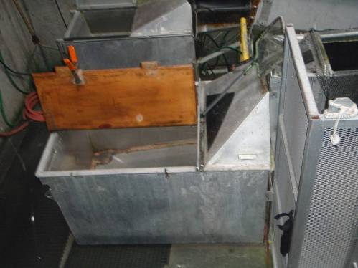

Anesthetic tank.

Brail pool exit.
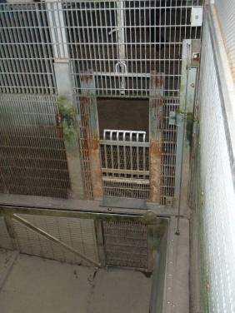
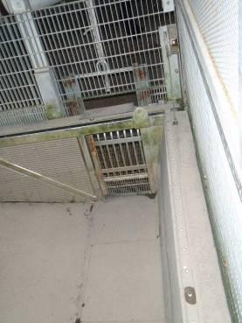

Pool in raised position.

Pool in lowered position.

Brail Pool.

Brail pool exit from the return pool side.
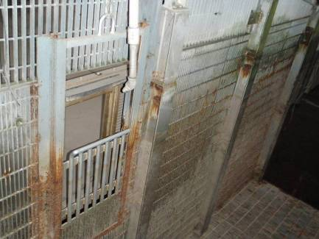

Lip before the return ladder. The concrete sill is about three or four feet high.
